
January 8th 2026

LENTEN NEWSLETTER
Dear Parents,
I would like to begin by wishing you all a very Happy New Year and say thank you for the lovely Christmas gifts that I received. Your generosity was very much appreciated.
Let us have a look what is in store this term?
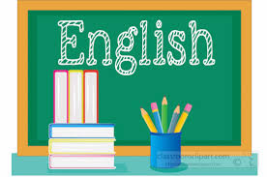
English
- Fiction: Fairytales and Fables
- Classic plays: Stories from Shakespeare
- Non-Fiction: Argument and debate.

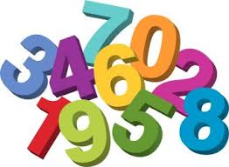
Mathematics
- Number: Multiplication and division.
- Measurement: Length and Perimeter
- Number: Fractions
- Number: Decimals
- Statistics

Science
- Forces
- Living things and their habitats

Topic
- History: Mayan Civilisation
- Geography: Rainforests

Religious Education
- Galilee to Jerusalem
- Desert to Garden

For more detailed information on other subjects such as Art, Music, PSHE etc. please browse the school website and view the class page or by subject.

Spelling and Homework
Spellings will continue to be administered weekly. New spellings are given each Monday morning.
Homework will continue to be administered through Century weekly. The homework supports the learning in the classroom and is extremely beneficial; therefore, I would appreciate your support in ensuring your child accesses the learning platform regularly.
Please do not hesitate to get in touch if you have any queries or concerns by phone on 01457 852756 or by email at grobinson@asg.srscmat.co.uk OR JSmith@asg.srscmat.co.uk
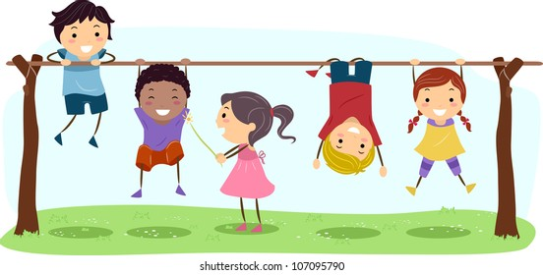

Kind regards,

Gail Robinson
Mrs. G Robinson

