Class 1 Newsletter September 2024

A warm welcome to all new children and their families, and to our super grown up Year 1’s!

Our topics for this term are:
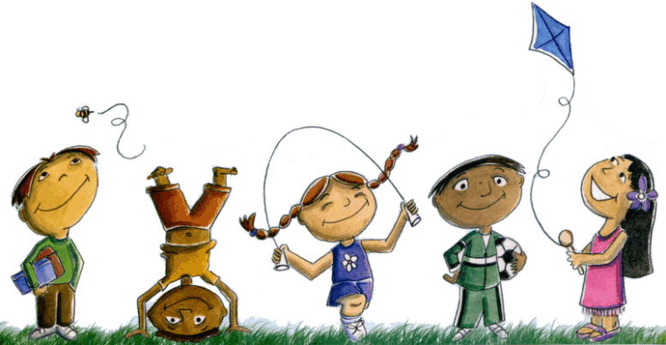
‘What makes me so amazing?’ – As we settle into our new class we will be exploring friendships and how to get along with each other. We will be reading stories with familiar settings and writing lists and labels. In science we will be learning about the parts of the human body and our five senses.

‘What toys did Grandma & Grandpa play with?’- This is a history based topic. Children will be discovering how toys have changed over the years, and how their toys differ from the ones their grandparents played with. In English we will be reading stories with repeating patterns and looking at the features of information books. In science we will be exploring everyday materials.

Our R.E. topics for the term are:
Creation and Covenant
Prophecy and Promise

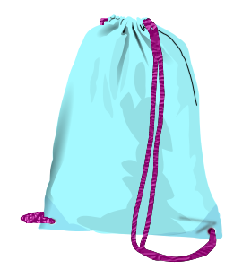
P.E.
P.E. lessons are on Thursday afternoon. P.E. kits consist of:-
- plain white polo shirt or T-shirt
- black jogging bottoms
- plain black sweatshirt
- pumps or trainers (with Velcro fastenings please – no laces!)
- For girls – a pair of socks if they come to school wearing tights!

Please ensure your child has a full P.E. kit in school in a drawstring bag, with their name on each item.
Drawstring bags can be purchased from the school office for £2.

Uniform
Please check that all items of school uniform, particularly jumpers and cardigans, are clearly labelled with your child’s name.
Items of clothing often get mixed up or misplaced, particularly on P.E. days, and it makes it much easier to return them to the right child if they are all named.

Homework
Homework will be given out on Fridays. This will consist of a phonics sheet (both reception and Year 1) and an additional piece of either maths or English homework for the Year 1’s. Please support your child with any homework and return to school by the following Friday.

Reading books
Reading books will be changed on Friday. However, please make sure that your child has their reading book and yellow reading record in their book bag each day as we may hear them read on other days. Bookbags can be purchased from the office for £4.
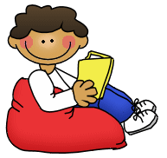
Please try to read with your child several times a week. As children read and reread the same book they begin to build up a sight vocabulary and improve fluency and expression. Please sign their yellow reading record book it each time they read with you.
Initially, reception children will choose a story book to bring home and share with an adult each week.

Water bottles and snacks
Please provide your child with a small water bottle (with their name on). All children are provided with a piece of fruit for a snack at playtime.

If you have any concerns or queries about anything in school, please do not hesitate to contact us.

Ms Ingham & Miss Shaw

