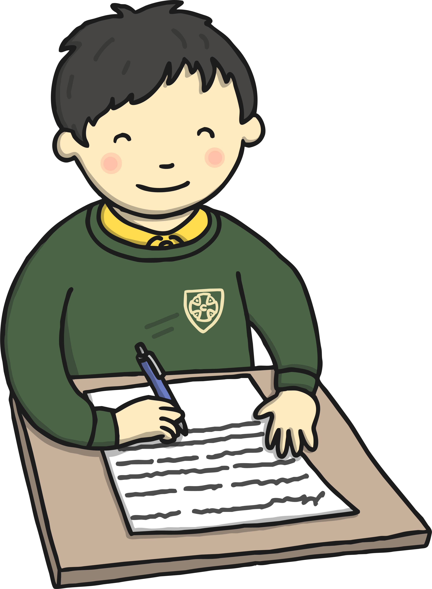
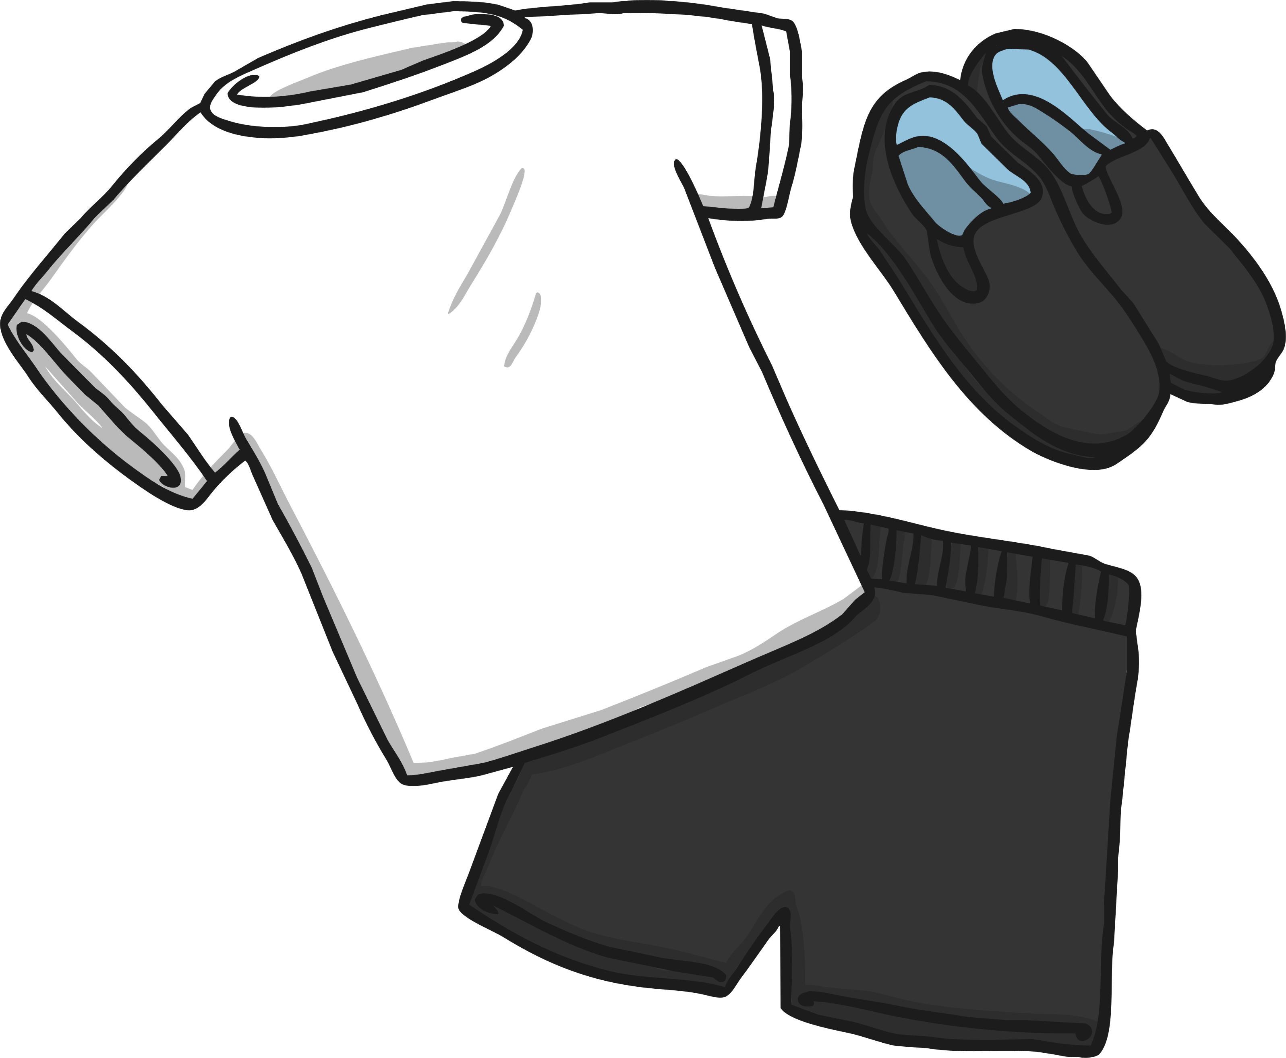
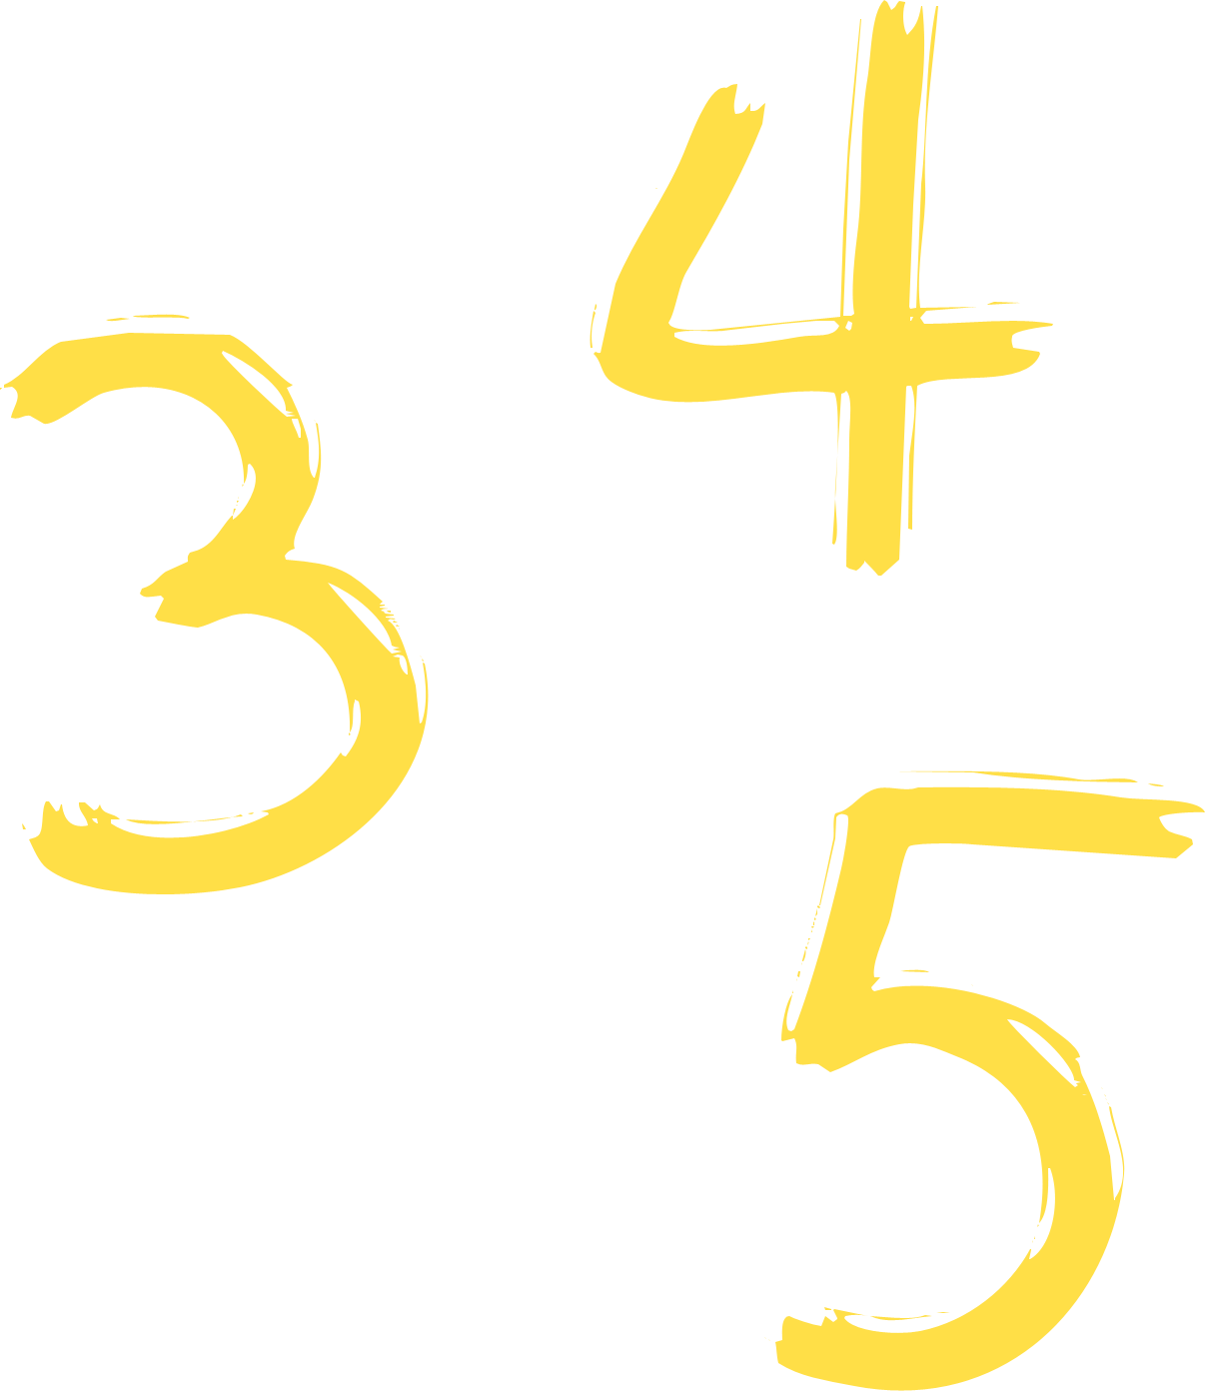
Class 2 Newsletter
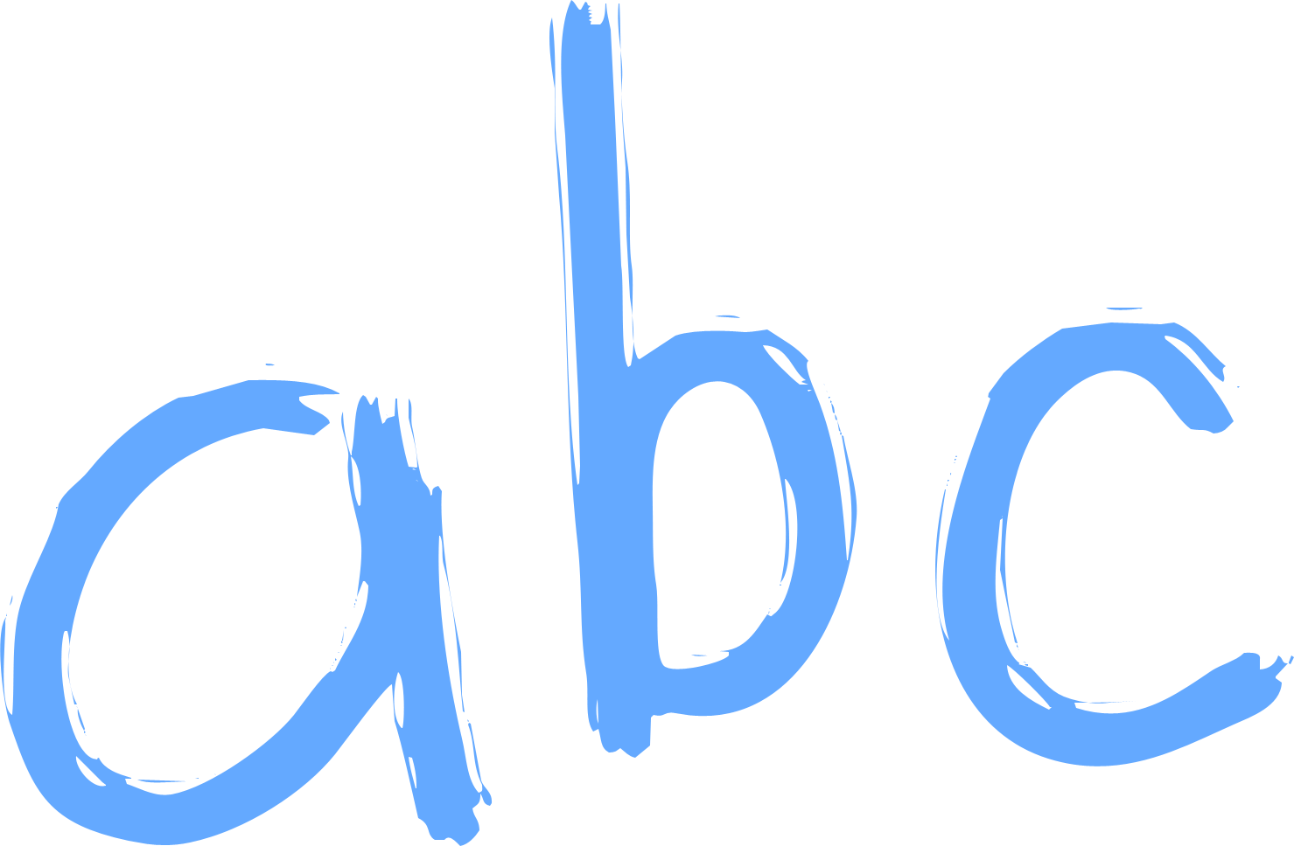
Advent Term
Dear Parents,
I hope you all had a wonderful summer break and are ready for a new school year.
I am looking forward to an amazing term and we have lots of fun to come!
Maths  This term, we will be covering:  - Place Value  - Addition and Subtraction  - Shape  - Multiplication and Division A | English  This term, we will be covering:  - Wellbeing Unit: Umbrellas and Rainbows  - Traditional Tales: Around The World  - Recounts: Space Travellers  - Stories on a Theme: Nature
Science  This term, we will be covering:  - Light  - Forces and Magnets | Topic  This term, we will be covering:  - Crime and Punishment  - Christmas
RE  This term, we will be covering:  - Creation and Covenant  - Prophecy and Promise | For more detailed information on other subjects such as Art, Music, PSHE etc please browse the school website and view the class page or search by subject.
Spelling and Homework
Spellings will be administered weekly. New spellings will be given out on a Tuesday and children will be tested on these the following Tuesday.
Homework will be given out on a Monday and will be collected in on a Friday.
Polite Reminders
Please ensure your child brings a water bottle to school daily which contains water.
Please also ensure that all clothing such as jumpers, cardigans and PE kits are all clearly labelled.
Please ensure you child has the correct PE kit – a kit list can be found on the school website.
If you have any concerns or queries, please don’t hesitate to contact me by phone on 01457 852756 or by email at mpickford@asg.srscmat.co.uk.
Thank You
Miss Pickford ☺

